Epsom & Ewell F.C.
26
v
Badshot Lea
Saturday, 9th April 2016 – 3.00 p.m.
Good afternoon! We welcome the players, supporters and officials of Badshot Lea Football Club for a League match, together with today’s match officials and our own regular supporters.

We met at Youngs Drive back in December; winning 1-0 with a free kick of the highest quality from Matt Ferdinando and I thought the result was fair and we were just the better side. We also defeated them 3-0 on their last visit, thanks to a memorable first home hat trick from Kyle Hough and these wins have improved our record against a club that we rarely defeated before then.

For those of you not at the Westfield match, everything was good, except the result! We had our largest league crowd since Guernsey visited over three years ago and lovely weather. On days like that, you wonder how much we would have raised had we been at our own ground, as catering and bar revenue was also very high for Chipstead F.C. Although we lost 2-0 to a goal in each half, the experiment of a Good Friday match clearly worked and we will be asking the league to provide us with a fixture on that date next season, so remember to keep that date in your diary clear!

As we talk about new grounds it is worth noting that Badshot Lea are now very close to a new ground and I am now hearing that Farnham Town will be moving within a year or two also. As our supporters will know, losing your ground is a very traumatic time and I take this opportunity to point out that we are still actively involved with a couple of sources with reference to our own return to the Borough. Much goes on behind the scenes that I am unable to release into the public domain at present, but rest assured, when something does happen we will let you know!

On Easter Monday, we were due to visit Raynes Park Vale, but this match was moved back to the Tuesday and then finally the Thursday, but it was worth waiting for as we won 3-0. Kyle Hough scored two goals, one of which involved a delicate chip from an angle that was far too good for this level of football, while Agi Panayiotou belted another in from 25 yards!

Then on Saturday we visited Guildford City, and produced a fine 5-1 win, despite playing striker Rob Hendry in goal and also conceding in the third minute. Kyle scored our equaliser while Daryl Cooper-Smith, Dan Dean and Tom Neale (2) scored the others. While we have had the midweek off, Badshot Lea have had two matches to play, the first of which was a 1-1 draw with Colliers Wood. The result of their Thursday meeting with Camberley Town was after our print deadline.

On Tuesday evening, we travel to AFC Hayes before returning here next Saturday for an extremely important visit from fellow promotion chasers Camberley Town. Please also note that our trip to Chessington & Hook United has now been rescheduled for Monday 2nd May.

Enjoy the game!

Rich

You can now follow us on Facebook: www.facebook.com/epsomandewellfc Twitter: @EEFCOfficial
and on Instagram at: www.instagram.com/epsomandewellfc

Cover Photos by Gemma Jarman

- Bentley Graham’s mazy run and shot secured the points at Farnham in the 90th minute
- Proof that Matt Farrell didn’t quite reach Tom Neale’s shot for our 4th goal at Guildford!

Cherry Red Records Combined Counties League
Premier Division Table 2015/16
inc Tuesday 5th April | P | W | D | L | F | A | Pts | GD | H | A
Hartley Wintney | 35 | 29 | 3 | 3 | 105 | 32 | 90 | +73 | 0-1 | 3-3
Ashford Town (Mx) | 36 | 25 | 3 | 8 | 94 | 49 | 78 | +45 | 30/4 | 3-2
Camberley Town | 34 | 23 | 6 | 5 | 73 | 29 | 75 | +44 | 16/4 | 1-1
Epsom & Ewell | 36 | 22 | 8 | 6 | 82 | 38 | 74 | +44 | - | -
Horley Town | 35 | 18 | 7 | 10 | 77 | 50 | 61 | +27 | 3-4 | 2-2
Hanworth Villa | 37 | 19 | 4 | 14 | 66 | 59 | 61 | +7 | 5-0 | 23/4
Colliers Wood United | 40 | 17 | 7 | 16 | 76 | 73 | 58 | +3 | 3-1 | 3-0
Knaphill | 34 | 17 | 4 | 13 | 75 | 53 | 55 | +22 | 1-2 | 1-1
Spelthorne Sports | 38 | 15 | 10 | 13 | 73 | 69 | 55 | +4 | 2-1 | 6-2
Raynes Park Vale | 36 | 16 | 3 | 17 | 67 | 72 | 51 | -5 | 3-1 | 3-0
Guildford City | 39 | 15 | 6 | 18 | 72 | 87 | 51 | -15 | 4-0 | 5-1
Windsor | 38 | 14 | 8 | 16 | 64 | 74 | 50 | -10 | 2-2 | 1-2
Bedfont Sports | 38 | 13 | 9 | 16 | 59 | 53 | 48 | +6 | 1-0 | 2-2
Farnham Town | 33 | 13 | 7 | 13 | 62 | 54 | 46 | +8 | 1-0 | 2-1
Badshot Lea | 36 | 14 | 2 | 20 | 52 | 85 | 44 | -33 | - | 1-0
Westfield | 32 | 12 | 7 | 13 | 46 | 55 | 43 | -9 | 0-2 | 0-0
Sutton Common Rovers | 36 | 13 | 4 | 19 | 61 | 74 | 43 | -13 | 3-1 | 2-1
AFC Hayes | 37 | 12 | 7 | 18 | 56 | 72 | 43 | -16 | 1-1 | 12/4
Chertsey Town | 37 | 11 | 7 | 19 | 52 | 68 | 40 | -16 | 0-1 | 5-3
Chessington & Hook | 30 | 7 | 3 | 20 | 45 | 77 | 24 | -32 | 1-0 | 2/5
Redhill | 33 | 6 | 4 | 23 | 46 | 76 | 22 | -30 | 3-0 | 1-0
Cove (R) | 38 | 3 | 1 | 34 | 27 | 131 | 10 | -104 | 1-0 | 7-0

Lucky Day? – 9th April
Played 20 - W 10 D 4 L 6 - F 35 A 33 - PPG 1.70 - Above Average
Our Club record against Badshot Lea
Played 16 - W 6 D 3 L 7 - F 27 A 32 - PPG 1.31 - Average
Largest wins and losses against Badshot Lea
21st March 2015 - W 3-0 - Combined Counties League (H)
2nd October 2010 - L 0-4 - Combined Counties League (A)
Their Last Visit
Saturday 21st March 2015 - W 3-0 - Combined Counties League

Club Manager – Glyn Mandeville
Good afternoon and welcome to High Road for our match against Badshot Lea.

I will start by welcoming their players, staff and supporters for today's game. I am sure it will be very tough, as it always is when these two teams meet up.

We come into today's game in good form and spirit after two very good results and hope to carry this on until the end of the season.

I would like to congratulate and wish Reisse Griffin and his wife all the best on the birth of their new baby boy on behalf of everyone at Epsom & Ewell.

I hope everyone enjoys today's game and have a safe trip home.

Manders

Club Captain - Sam Currie
Good afternoon and welcome to High Road for this afternoon’s encounter with Badshot Lea. We welcome the squad, management team and their supporters for what should be another tough game.

Earlier in the season we played away to Badshot in the middle of December in heavy conditions on a pitch that didn't really suit our style of play and another game where we had to find a different solution to gaining all three points.

On that occasion we had "Ferdy" to thank for a belter of a free kick.

Recently we have started playing some good stuff again after a subdued start to the month and recent away victories to Raynes Park and Guildford City have seen us find the back of the net on several occasions whilst looking solid at the back, again on two pitches which weren't the best to allow football to be played to its full potential.

Most impressively one of those games was with our forward Robbie Hendry in goal - for which the whole squad is more than thankful to him!

We all know that at the end of the season we have some big games in terms of two of the top three coming here, and so today is a must win if we want to go into those games with the belief we still have that we can be well involved at the top come the end of the season.

We wish you a safe journey home following today's game and thank you for your continued support as always. "Up the Salts"

Sam

Latest Results and Fixtures
Combined Counties League – Wednesday 23rd March
Guildford City | 2-5 | Hartley Wintney
Combined Counties League – Friday 25th March
Epsom & Ewell | 0-2 | Westfield
Combined Counties League – Saturday 26th March
Ashford Town (Mx) | 1-1 | Hartley Wintney
Bedfont Sports | 2-2 | Spelthorne Sports
Camberley Town | 3-0 | AFC Hayes
Chessington & Hook United | 0-3 | Badshot Lea
Cove | 0-2 | Windsor
Farnham Town | 3-1 | Raynes Park Vale
Hanworth Villa | 2-0 | Chertsey Town
Knaphill | 4-1 | Guildford City
Redhill | 3-0 | Colliers Wood United
Sutton Common Rovers | 4-0 | Horley Town
Combined Counties League – Monday 28th March
Guildford City | 0-1 | Sutton Common Rovers
Horley Town | 4-0 | Redhill
Combined Counties League – Wednesday 30th March
Colliers Wood United | 2-1 | Chessington & Hook United
Hartley Wintney | 2-0 | Cove
Windsor | 2-1 | Knaphill
Combined Counties League – Thursday 31st March
AFC Hayes | 0-1 | Bedfont Sports
Farnham Town | 1-1 | Camberley Town
Raynes Park Vale | 0-3 | Epsom & Ewell
Spelthorne Sports | 2-3 | Hanworth Villa
Combined Counties League – Saturday 2nd April
AFC Hayes | 3-1 | Redhill
Badshot Lea | 0-1 | Bedfont Sports
Chertsey Town | 1-4 | Camberley Town
Colliers Wood United | 2-2 | Farnham Town
Cove | 1-0 | Sutton Common Rovers
Guildford City | 1-5 | Epsom & Ewell
Horley Town | 3-2 | Ashford Town (Mx)
Raynes Park Vale | 0-1 | Knaphill
Westfield | 4-0 | Hanworth Villa
Windsor | 0-3 | Hartley Wintney
Combined Counties League – Tuesday 5th April
AFC Hayes | 2-2 | Westfield
Badshot Lea | 1-1 | Colliers Wood United
Camberley Town | 2-1 | Redhill
Latest Results and Fixtures
Combined Counties League – Tuesday 5th April
Cove | 1-2 | Chertsey Town
Knaphill | 2-2 | Chessington & Hook United
Raynes Park Vale | 1-0 | Bedfont Sports
Combined Counties League – Thursday 7th April
Badshot Lea | V | Camberley Town
Farnham Town | V | Knaphill
Redhill | V | Chessington & Hook United
Combined Counties League – Saturday 9th April
Ashford Town (Mx) | V | Guildford City
Bedfont Sports | V | Colliers Wood United
Camberley Town | V | Raynes Park Vale
Chessington & Hook United | V | AFC Hayes
Epsom & Ewell | V | Badshot Lea
Farnham Town | V | Chertsey Town
Hanworth Villa | V | Cove
Hartley Wintney | V | Horley Town
Knaphill | V | Spelthorne Sports
Redhill | V | Westfield
Sutton Common Rovers | V | Windsor
Combined Counties League – Tuesday 12th April
AFC Hayes | V | Epsom & Ewell
Chessington & Hook United | V | Hartley Wintney
Farnham Town | V | Sutton Common Rovers
Knaphill | V | Hanworth Villa
Raynes Park Vale | V | Redhill
Westfield | V | Horley Town
Combined Counties League – Thursday 14th April
Chessington & Hook United |  | Horley Town
Farnham Town | V | Westfield
Combined Counties League – Saturday 16th April
AFC Hayes | V | Sutton Common Rovers
Badshot Lea | V | Knaphill
Chertsey Town | V | Hartley Wintney
Cove | V | Colliers Wood United
Epsom & Ewell | V | Camberley Town
Guildford City | V | Chessington & Hook United
Horley Town | V | Farnham Town
Raynes Park Vale | V | Hanworth Villa
Spelthorne Sports | V | Redhill
Westfield | V | Bedfont Sports
Windsor | V | Ashford Town (Mx)

From behind the goal
Epsom & Ewell 0-2 Westfield
Combined Counties League – Premier Division - Friday 25th March 2016

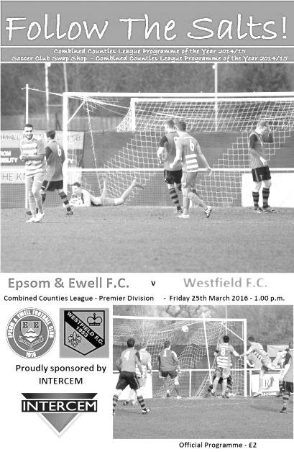
Salts fail to turn up for Friday match

Recent results have been positive for the Salts, even though the performances have been below what we had been producing earlier in the season. On Friday it finally caught up with us as we produced a very flat performance from first to last and thoroughly deserved to lose to visiting Westfield in front of an encouraging but mostly disappointed crowd of 116 at High Road.

We often say that there are no easy games in this league and this was proved correct as fourth from bottom Westfield were in charge for the majority of the match against a disjointed Epsom team that struggled to create any meaningful opportunities throughout the entire ninety minutes. Despite coming into this game with four straight defeats and facing the trip to Chipstead with an entirely new management team, following their resignation on Tuesday should have been daunting enough against a team third in the table and chasing a promotion place, but they chased everything down and denied us any space.

For our part we rotated the squad a little with both Matt Farrell and Craig Hastings starting on the bench and we persisted with our 3-5-2 formation. But right now, whichever formation we are using, we seem to be creating little in the way of real chances. Tom Neale had an early effort from fully thirty yards but it didn't trouble their keeper Stuart Norman. Most of the football was being played at the other end and a harmless looking ball through to Michael Eacott was misjudged as Andrew Mensah just got a toe to the ball in front of him and was then able to walk the ball into the net in the 25th minute.

We nearly conceded again a few minutes later when a defensive header was sent

back past the advancing Eacott but we were able to recover from that position and our keeper was able to get back in time to block the shot when it arrived. However, as half time approached there were still no signs of life and a Westfield free kick just cleared Eacott's bar just before the break.

Hastings came on for the injured George Murphy shortly after the restart but a second goal arrived after 51 minutes. A Westfield corner was palmed away from the danger area by Eacott. Maybe he could have got a firmer connection although it still went a little way. However, we didn't react at all to the second ball and the loose ball was drilled back in to the net by Ryan Marklaw.

Neale found himself surrounded but still managed to get a shot on target from just inside the penalty area, although this was tipped over by Norman. We had another scare at the other end when Eacott appeared to bring down the Westfield striker in the penalty area, but the referee awarded a free kick the other way and confirmed after the match that there was a foul prior to our keeper's challenge. Just as well as it would surely have resulted in a red card.

Rob Hendry and Matt Farrell joined the fray for Matt Tanton and Sam Currie and they combined well with Hendry's corner being met by Farrell's overhead kick but it was an ambitious attempt and drifted harmlessly high and wide. We tried to push for a way back but with little in the way of penetration and our chances were ended with the sending off of Elliott Thompson in the 82nd minute for a dangerous challenge out on the touchline.

In second half injury time we finally fashioned a chance worthy of the name when Hendry put Kyle Hough through on the left and his pull back to Neale resulted in a powerful shot at goal but we never found out whether it would have beaten their keeper as it was quickly blocked by a covering defender, which summed the match up.

Full credit to the visitors who are surely too good to go down, despite their form going into this match and who also recorded their first ever result from an away trip to Epsom, having been defeated on their previous nine visits. They never looked like being beaten today and we now have a few questions to answer on Monday morning at Raynes Park Vale, as any further points dropped will surely mean the end of our chances of finishing in the top two. Some might say that opportunity has already gone, following this defeat.

Team: Michael Eacott, Reisse Griffin, Matt Tanton, James Taylor, Dan Dean, George Murphy, Elliott Thompson, Sam Currie (c), Kyle Hough, Tom Neale, Bentley Graham

Subs: Craig Hastings for Murphy (47), Rob Hendry for Tanton (62),
Matt Farrell for Currie (62)

From behind the goal
Raynes Park Vale 0-3 Epsom & Ewell
Combined Counties League – Premier Division - Thursday 31st March 2016

Fourth straight win at Grand Drive puts Salts back on track

Confidence is a funny thing. The last few matches have been tight and scrappy, but once we had taken a lead all those worries seemed to drift away and we played some nice football on a surface that cut up a little but wasn't nearly as bad as feared, following recent water related postponements.

Grand Drive is a good venue for us. In eleven visits there to play the Vale, whether Malden or more recently Raynes Park, we now have seven wins against just two defeats and ever since Robbie Burns fired in that late winner to set our new club record of 12 straight League wins back in 2012/13 we have had a perfect record here.

There were some notable changes in our line-up for this match. Matt Tanton was away as was James Taylor, so Rhys North and Craig Hastings came back into the starting eleven and behind them we had new signing Alistair Turpie between the posts to make his debut with Michael Eacott on the bench. Up front Rob Hendry replaced Tom Neale, while Matt Ferdinando returned from his suspension with Matt Farrell starting again too in place of Elliott Thompson and George Murphy.

We started up the hill as is so often the case here and took the lead in the 19th minute when a right wing cross was headed out by a defender, but the ball fell straight to Kyle Hough who drilled it inside the left hand post of Alex Sykes to give us a great start.

Turpie had little to do in the first half, although he was down smartly to cover a low shot as the home side attempted an instant response and although there weren't too many chances our build up play was good. In fact the only bad news was an enforced substitution after Ferdinando fell awkwardly and had to come off. Savvas 'Agi' Panayiotou took his place for the final few minutes of the first half, which ended with a disallowed Hough goal after he was flagged offside when receiving Hendry's clever pass.

I always prefer us to head down the hill in the second half as it seems much more difficult to defend, and this was proven to be the case once again as Hough scored a second goal within two minutes of the restart. From just inside the box, he beat two men before producing a chip from an angle with his weaker right foot that Johan Cruyff would have applauded; the ball dropping over Sykes and just under the bar for an exquisite second goal.

Mention has already been made of the array of really special goals our boys have already produced this season and six minutes after Kyle's super effort we had another to witness as Agi collected the ball around 25 yards out and let fly into the top corner. Sykes did well to get a hand to it, but the ball was struck too powerfully and we were 3-0 up.

With plenty of time left there was a hope that more goals would follow but it wasn't to be. In fact Turpie also had his busy moments, including an interesting moment where he called for the ball but one of our defenders knocked it out to a Vale striker and his shot was excellently diverted wide of the post by our retreating keeper. He made another low save after this, although I thought our clean sheet had disappeared in the 79th minute when their man took the ball around him and planted the ball in the net, only to be denied by an offside flag that was either raised late or spotted late. This was understandable as viewing was extremely difficult at times under the lights.

In injury time we cut Vale apart with a nice move but Sykes made a great block from Farrell's close range strike and the danger was eventually cleared. All in all though, it was a great response to our recent home defeat against Westfield and it must be remembered as we make the trip to Guildford on Saturday that we have still only lost one away league match all season. Our challenge for second place is still alive for the time being and we just have to keep winning if we are to have any chance of overhauling Ashford Town (Mx). We did reclaim third place though as Camberley were held at Farnham Town the same evening.

Team: Alistair Turpie, Rhys North, Sam Currie (c), Dan Dean, Craig Hastings, Bentley Graham, Reisse Griffin, Matt Farrell, Kyle Hough, Rob Hendry, Matt Ferdinando

Subs: Savvas 'Agi' Panayiotou for Ferdinando (42), Elliott Thompson for Currie (70), Tom Neale for Hough (72)

Player Profile – Number 19 – Tom Neale
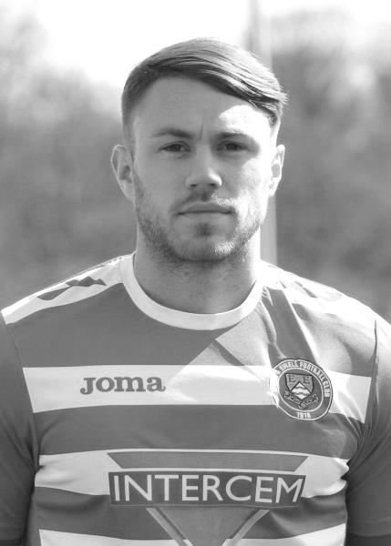
Our latest profile is from another of our newer players, Tom Neale.

Age: 26

Position: Striker / left wing

Club supported: Fulham

Favourite Meal: Anything with protein

Favourite Film: Man on Fire

Messi or Ronaldo: Ronaldo

Favourite Drink: Vodka, lemonade and lime

Favourite Ground played at: Craven Cottage

Best moment for Epsom: Coming on and scoring from 30 yards against Sutton Common Rovers in December

Describe the Gaffa in three words: Going - Going - Gone

Tom’s Playing Stats: First Team Debut : 13/10/2015

Appearances: 16 - Sub: 13 - Total: 29 - Goals: 9

Club Records - 9th April
Date | Day | Competition |  | Opponents |  | Scorers
09/04/28 | Mon | London League | H | Walthamstow Grange | 4-0 | R.Marlow (2), F.Behn, F.Watts
09/04/32 | Sat | London League | A | Grays Athletic | 2-1 | B.Williams (2)
09/04/38 | Sat | London League | H | Tilbury | 5-2 | J.Jones (4, 1 pen), B.Solly
09/04/49 | Sat | London League | H | Chingford Town Reserves | 5-0 | B.Cutter (3), R.Hunt, F.Chitty
09/04/52 | Wed | Friendly | H | Leatherhead | 3-0 | B.Goddard (3)
09/04/55 | Sat | Corinthian League | A | Erith & Belvedere | 0-6
09/04/62 | Mon | Corinthian League | A | Maidenhead United | 0-7
09/04/63 | Tue | Corinthian League | A | Maidenhead United | 0-3
09/04/66 | Sat | Athenian League 2 | H | Lewes | 0-0
09/04/71 | Fri | Athenian League 2 | H | Wingate | 1-5 | D.Webb
09/04/74 | Tue | Surrey Senior League | H | Horley Town | 2-2 | D.Ritman (pen), M.Talmage
09/04/83 | Sat | Isthmian League 1 | A | Walton & Hersham | 3-0 | S.Hill, S.Milton, R.Lewis
09/04/88 | Sat | Isthmian League 2s | H | Banstead Athletic | 1-0 | M.Cossey
09/04/91 | Tue | Isthmian League 2s | H | Malden Vale | 1-2 | D.Fry (pen)
09/04/94 | Sat | Isthmian League 3 | A | Oxford City | 0-3
09/04/02 | Tue | Isthmian League 3 | H | Clapton | 3-0 | J.Hall, J.Rogers, B.Stevens
09/04/05 | Sat | Isthmian League 2 | H | Enfield | 2-1 | M.Owen, L.Purvis
09/04/07 | Mon | Combined Counties  Premier Division | H | Banstead Athletic | 0-0
09/04/11 | Sat | Combined Counties  Premier Division | H | Bookham | 1-1 | D.Marvell
09/04/12 | Mon | Combined Counties  Premier Division | H | Banstead Athletic | 2-0 | J.Cottee, B.Hayward
Historical Decades
90 years ago – Epsom Town F.C.
10/04/26 | Sat | Surrey Senior League | H | Addlestone | 5-1 | H.Streeter (2), J.Parr (2), R.Marlow
80 years ago – Epsom F.C.
10/04/36 | Fri | London League | A | Tooting & Mitcham United | 2-4 | H.Pullen, V.O'Connor
70 years ago – Epsom F.C.
13/04/46 | Sat | Friendly | H | Golders Green | 3-1 | K.Holliday (2), R.Marlow
60 years ago – Epsom F.C.
07/04/56 | Sat | Corinthian League | H | Erith & Belvedere | 5-0 | T.Murphy (3), N.Ambrose, o.g.
50 years ago – Epsom & Ewell F.C.
09/04/66 | Sat | Athenian League 2 | H | Lewes | 0-0
40 years ago – Epsom & Ewell F.C.
10/04/76 | Sat | Athenian League 2 | A | Epping Town | 2-0 | T.Tuite, o.g.
30 years ago – Epsom & Ewell F.C.
08/04/86 | Tue | Isthmian League  Premier Division | A | Farnborough Town | 3-2 | R.Kidd (pen), D.Jones, R.Strong
20 years ago – Epsom & Ewell F.C.
08/04/96 | Mon | Isthmian League 3 | H | Camberley Town | 4-0 | G.Meakin, A.Boxall, S.Miller, B.Forey
10 years ago – Epsom & Ewell F.C.
08/04/06 | Sat | Isthmian League 2 | H | Ware | 1-2 | P.N'gbale

History Corner - 9th April
90 years ago this week we smashed Addlestone 5-1 at West Street on our way to our first Surrey Senior League title. H.S. Streeter, a player who had actually scored for Sutton United to hand us our first ever competitive defeat at our new ground the season before, scored twice as did Jack Parr, while record breaking Reg Marlow only got one this day.

78 years ago today our clever inside-left Jimmy Jones scored four times and Basil Solly got the other one as we crushed Tilbury by five goals to two in a London League fixture. Home sides held the sway in this fixture throughout the thirties with just one Epsom away win from 21 fixtures.

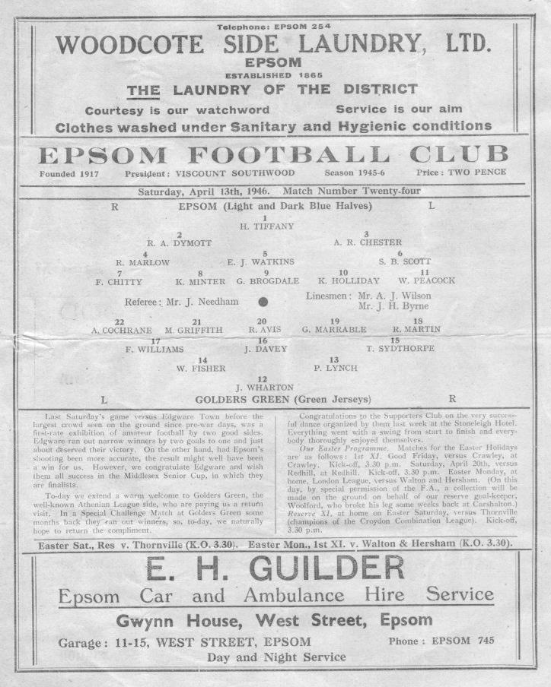
70 years ago this week we defeated Golders Green 3-1 at West Street with two goals from Ken Holliday and one from Reg Marlow’s adopted son Roy. Golders Green would shortly change their name to Hendon F.C. and contained within their line-up this day a young Pat Lynch, an England Amateur International and future Epsom F.C. Manager from 1952-55, together with another future Epsom player in Bobby Avis. (see programme right)

67 years ago today our regular centre-half Bill Cutter played up front and scored a hat trick in our 5-0 win over Chingford Town Reserves at West Street.

64 years ago today it was a more regular striker, Bill Goddard, who would be finding the net three times as Leatherhead were defeated 3-0 in a friendly challenge match at home. He would continue this form into 1952/53 where he would hit 54 goals the following season to set a post war record that still stands.

60 years ago this week we defeated Erith & Belvedere 5-0 at home in a Corinthian League fixture. Ted Murphy scored a hat trick and would famously go on to play for Tooting & Mitcham United and later Wimbledon, where he would receive an Amateur Cup Winners medal in 1963.

30 years ago this week we were battling against relegation from the Isthmian League Premier Division and with just one away win in the league all season, this trip to Farnborough looked tricky. However, we fought hard and a superb long range winner from young striker David Jones enabled us to survive for another day with this 3-2 win, although we would still go down.

First Eleven Appearances - (max 41 including Guildford City – 02/04/16)
Name | Debut | 2015/16 |  |  |  | Career Totals
 |  | App | Sub | Total | Goals | App | Sub | Total | Goals
AJAYI Tayo* | 22/08/2015 | 0 | 2 | 2 | 0 | 0 | 2 | 2 | 0
COOPER-SMITH Daryl | 03/01/2015 | 16 | 4 | 20 | 9 | 25 | 7 | 32 | 15
CURRIE Sam | 04/08/2012 | 21 | 5 | 26 | 1 | 129 | 14 | 143 | 3
DAVISON Conor* | 22/08/2015 | 1 | 2 | 3 | 0 | 1 | 2 | 3 | 0
DEAN Dan | 02/08/2014 | 26 | 3 | 29 | 1 | 62 | 4 | 66 | 1
DOWNS Carl | 17/09/2011 | 5 | 1 | 6 | 0 | 99 | 14 | 113 | 2
EACOTT Michael | 02/08/2014 | 34 | 0 | 34 | 0 | 80 | 0 | 80 | 0
FARRELL Matt | 02/08/2014 | 39 | 1 | 40 | 7 | 80 | 4 | 84 | 14
FERDINANDO Matt | 20/09/2014 | 25 | 2 | 27 | 8 | 52 | 6 | 58 | 14
GRAHAM Bentley | 09/02/2016 | 11 | 1 | 12 | 2 | 11 | 1 | 12 | 2
GRIFFIN Reisse | 08/08/2015 | 22 | 6 | 28 | 1 | 22 | 6 | 28 | 1
HASTINGS Craig | 08/08/2015 | 33 | 4 | 37 | 0 | 33 | 4 | 37 | 0
HATFIELD Jamie | 11/11/2006 | 1 | 0 | 1 | 0 | 249 | 13 | 262 | 6
HENDRY Rob | 08/08/2015 | 29 | 8 | 37 | 12 | 29 | 8 | 37 | 12
HOUGH Kyle | 14/08/2007 | 31 | 4 | 35 | 24 | 327 | 19 | 346 | 195
JONES Adrian | 06/08/2011 | 4 | 1 | 5 | 0 | 24 | 1 | 25 | 0
KURDZIEL Jakub* | 29/08/2015 | 1 | 0 | 1 | 0 | 1 | 0 | 1 | 0
MARVELL Dale* | 15/01/2000 | 8 | 4 | 12 | 1 | 269 | 49 | 318 | 86
McGREGOR Alex* | 08/08/2009 | 7 | 3 | 10 | 2 | 179 | 59 | 238 | 29
MCKAY Alex | 20/12/2008 | 23 | 1 | 24 | 0 | 108 | 27 | 135 | 8
MURPHY George | 19/03/2013 | 2 | 1 | 3 | 0 | 68 | 7 | 75 | 3
NEALE Thomas | 13/10/2015 | 16 | 13 | 29 | 9 | 16 | 13 | 29 | 9
NEILL David* | 03/10/2015 | 1 | 1 | 2 | 0 | 1 | 1 | 2 | 0
NORTH Rhys | 16/08/2015 | 17 | 7 | 24 | 1 | 17 | 7 | 24 | 1
OLIVER Beckett* | 29/08/2015 | 5 | 11 | 16 | 0 | 5 | 11 | 16 | 0
PANAYIOTOU Savvas | 03/01/2015 | 10 | 5 | 15 | 2 | 26 | 8 | 34 | 5
ROBINSON Sam* | 22/10/2011 | 0 | 1 | 1 | 0 | 54 | 5 | 59 | 13
ROWE Steve | 27/08/2011 | 0 | 1 | 1 | 0 | 24 | 3 | 27 | 0
SMITH Matt | 08/08/2009 | 0 | 0 | 0 | 0 | 91 | 43 | 134 | 10
TANTON Matt | 02/08/2014 | 34 | 0 | 34 | 0 | 52 | 4 | 56 | 1
TAYLOR James | 26/08/2013 | 24 | 4 | 28 | 3 | 80 | 12 | 92 | 6
THOMPSON Elliott | 09/02/2016 | 4 | 7 | 11 | 0 | 4 | 7 | 11 | 0
TURPIE Alistair | 31/03/2016 | 1 | 0 | 1 | 0 | 1 | 0 | 1 | 0
Own Goal |  |  |  |  |  |  |  |  | 1
* Player has left the club

Badshot Lea F.C. – History
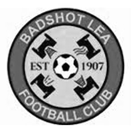
Early history suggests that the village football club was formed in 1904, after a meeting at the local village hall. They initially played friendly matches before deciding that they affiliate to the Surrey County Football Association in 1907.

They began life in the junior leagues before gradually progressing through the leagues. The most recent history shows the Lea playing in the Aldershot leagues and progressing through the various divisions, eventually obtaining promotion to the Surrey Intermediate League Western in 1978.

Progress through the three divisions saw the Lea eventually promoted to the Surrey Premier League in 1986. This was for one year only as we obtained the dubious distinction of being relegated with the highest points total ever achieved by a side being relegated.

Season 1988 saw us again in the Surrey Intermediate League Western. The ensuing years saw the ups and downs that one experiences until season 2002/03 which saw eventual promotion to Senior Football via The Hellenic League. This was not without its problems as The FA at Soho Square tried to block the move. It was only the determination of the committee and the full backing of The Hellenic League that eventually saw us given the green light.

In our first season we took time to adjust to Senior Football eventually finishing 4th from bottom under the guidance of manager Maurice Gregory. Season 2004/05, David Ford took over the management reigns with Nathan Fealey and in their first season took the side to a credible 7th place finish. Season 2005/06 saw the 1st team finish mid table and reach two cup finals. They narrowly lost out to Sandhurst Town in the Aldershot Senior Cup on penalties but beat Penn & Tylers Green in the Hellenic Supplementary Cup.
2006/07 saw them yet again lose out on penalties in the Aldershot Senior Cup this time against Camberley Town. On the league front they produced some fantastic football all season and after chasing Bisley Sports for most of the season ended up finishing in 3rd place. It was enough to enable up to take up a promotion position and with a groundshare secured with near neighbours Farnborough we were able to do so.

2007/08 season under the guidance of Dave Ford we finished our first season at Step 5 in a respectable 11th place and beaten finalists in the Aldershot Senior Cup losing by the odd goal against Fleet Town. The National League’s Committee then sanctioned a move to the Combined Counties Premier League for season 2008/09 where we swapped places with Reading Town.

Season 2009/10 saw us reach the 2nd qualifying round of the F.A. Cup as well as reaching the 3rd round proper of the F.A. Vase. We also reached the Semi Final of the Surrey Senior Cup beating Woking on the way.

Season 2010/11 saw us finish 6th in the league and finally win the Aldershot Senior Cup defeating Fleet Town on penalties. Season 2011/12 saw us finish in a disappointing league position, the lowest at Step 5. We still managed to get to a Cup Final at Aldershot Town, where we lost out to Ashford Town (Middx) in The Aldershot Senior Cup Final.

Season 2012/13 saw Mark Anderson replace Dave Ford as manager and he finished in an excellent 7th place and also led the team to the FA Cup 3rd Qualifying round where after beating Ryman League sides Folkestone Invicta and Premier side Leiston, finally lost out to Southern Premier side Chippenham Town.

Mark Anderson resigned for personal reasons in July 2013 and the club appointed Ryan Scott and Nick Sowden as joint managers. In November 2013 Trevor Norris was appointed and he steered us to a safe position at the end of the 2013/14 season. In September 2014 Trevor Norris resigned his position as manager and was replaced by Mark Thomas. He was joined by James Reeves and Coach Darren Barnard.

The 2013/14 season was a strange one. A slow start was replaced by a run of blistering form as the club raced up the table, only to fall away a little towards the end and a satisfactory 8th place was the final position. Now with a new ground closer to reality the future is bright.

Centre page for results

Centre page for results

Every Opponent A-Z
Over the years we have played many, many different opponents. Exactly how many is a difficult question, as it all depends on your definition. Are Camberley & Yorktown different to Camberley Town, or are Epsom Town different to Epsom F.C. or Epsom & Ewell F.C.?

In my analysis I have classed them as the same team, and will work through them all from A to Z. Some we have played many times, whilst others we have met just once or twice. Enjoy!

Shoreham: held over to next issue

Slough Town: Played 47 - W9 D9 L29 - F72 A121 - PPG - 0.77 - Poor

The Rebels have not been a good side for us to face over the years. Whether the matches were at The Dolphin Ground, Wexham Park, or even Stag Meadow, defeats have come frequently. In fact, against Slough we recorded a club record eleven straight defeats away from home!

They were founded in 1890 and although our war time outfit Epsom Town met Slough United as they were temporarily called in the inaugural Corinthian League season of 1945/46 (naturally losing both matches) we had to wait until we joined that league in 1949/50 for our first meetings, by which time they had split with Slough Centre and renamed themselves Slough Town once again. We were narrowly defeated 3-2 on 12th November 1949 at West Street, despite goals from the two Freds, Marshall and Chitty, and we secured a 1-1 draw on our first ever visit to The Dolphin Ground, by that time a dual use Greyhound Stadium, on 14th January 1950. In fact, over our 22 visits to Slough’s ground, we have recorded a paltry two wins and four draws, so this was quite a good result looking back!

The following season we were not so fortunate there, losing 2-1 and being hammered 6-1 at the end of the season at West Street, although there was some consolation taken from the fact that we had just lost to the Champions. Slough would remain one of the best teams in the Corinthian League and we had the misfortune to meet them at least twice a season from this point until our relegation from the newly merged Athenian League in 1965.

Our most successful season in that league was in 1952/53 when we finished third, and we achieved a 3-3 draw over there after an early season 2-1 win had set us on our way with goals from Frank Lee and Bill Goddard who would go on to score 54 goals that season.

The following season we won 2-0 at West Street with goals from the pairing of Vic Honey and Denis Ford. For those who remember long serving helper Wilf Smith from our West Street days, he thought Vic Honey looked familiar and then realised that he had been his Staff Sargeant in Malaya during World War Two! Our return visit resulted in a 5-1 defeat!

The next two seasons 1954/55 and 1955/56 were good ones as we recorded three draws and our first win at the Dolphin, 3-2 on Wednesday 2nd May 1956 with a couple of goals from Jan Sorensen and the other from Ted Murphy. The two draws in 1954/55 were most surprising though as we actually finished bottom of the league that year!

In 1956/57 we had a very good year and were on for a League and Cup double under the stewardship of Fred Chitty, although were destined to miss out on both in the final week, ending up in fourth place. We played Slough four times that season, both winning our home league matches, and although we drew at home in the Memorial Shield, we recorded our only other win at Slough on 2nd February 1957 when our free scoring side, led up front by Johnny Bangs won 5-2 there, with Bangs himself scoring a hat trick. Dave Hermitage and an own goal completed the rout.

However, we lost our next seven matches, including a tie in the fledgling Southern Combination Cup on 16th September 1959. We had a great team and won the Memorial Shield for the only time in our history, but our two League meetings that season had already taken place by the time of this third defeat in a month and our team only started to strengthen midway through the season.

Our opening match of 1960/61 was also against Slough as we opened up our defence of the Shield with a home 2-2 draw and our 3-0 defeat in the replay the following Saturday ensured we would have held it for just 119 days! We also lost there in the league, although did win our home match 5-4 after trailing 2-1 at the half. Slough would actually finish bottom of the league this season.

We both won home league matches in 1961/62 but lost again in the Memorial Shield by a single goal at the Dolphin and then lost our next six league matches up to 1965. We were also paired three seasons in a row in the F.A. Cup, but we did manage a win in one of these, 2-1 on 7th September 1963. Our 4-1 defeat on 6th March 1965 was the last time we would ever play at the Dolphin Ground which was sold for housing in 1973. The club moved to Wexham Park for 1973/74.

Our relegation ensured that we did not meet for nearly twenty years. In fact 1973 is a good time to show a comparison; just as we were thrown out of the Athenian League in 1973 they were playing at Wembley in the Amateur Cup Final! It was a big hole to climb out of but in 1984 we were able to proudly take our place alongside them as members of the Isthmian League Premier Division.

Wexham Park - seen in better days

Although leading by a Steve Milton goal at half time on our first visit to Wexham Park, we were defeated 2-1 on 22nd September 1984, and lost a two goal lead in a 2-2 draw at West Street in April. However, in 1985/86 we were relegated, even though we recovered a two goal deficit of our own that year, coming from 4-2 down to draw 4-4 on our last visit to their new ground on 21st January 1986 and then winning the return on Easter Saturday by two goals to one. I can still recall Andy Dear’s winner at the top goal at West Street!

Slough themselves had difficulties too and by the time we met them for what would be the final times, in 2003/04 we were in the Isthmian League Division One South. They had been relegated in 2001 and were transferred over from the North Division. Additionally, they had also lost their ground at Wexham Park in 2003 so were sharing at Stag Meadow, home of Windsor and Eton F.C. where they would remain for four seasons. We were dreadful this year, while they would be promoted. Their first ever match in the post Wexham era was at Merland Rise where they beat us 4-1 on opening day and on 13th December 2003 our last ever meeting was a crushing 7-1 defeat.

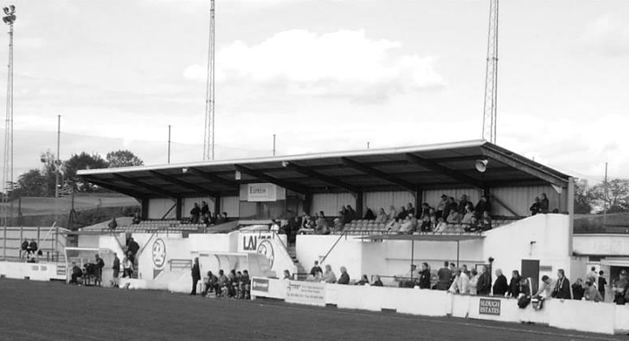
They left Windsor to share at Beaconsfield SYCOB in 2007 and remain there to this day, but are close to securing a new ground at Arbour Vale, while Wexham Park sadly rots away; the club having left after a dispute with their landlords. Slough currently compete at Step Three in the Southern League Premier Division but with a new ground they may even end up back in the Conference National; a League they graced for almost a decade in the nineties.

From behind the goal
Guildford City 1-5 Epsom & Ewell
Combined Counties League – Premier Division - Saturday 2nd April 2016

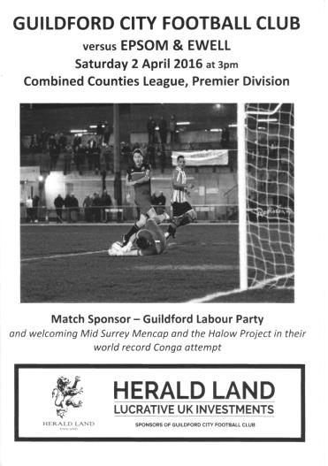
Hendry the latest "have a go hero" in yet another five star Salts away day display

Despite playing less than 48 hours previously, our boys produced another superb away display, scoring at least five goals away from High Road for the fourth time this League season already.

Our 4-0 win over Guildford in December was arguably one of our best displays of the season and this latest win was equally important, keeping us in the hunt for the second place finish that would secure promotion, following confirmation that Champions elect Hartley Wintney will be unable to move up.

I'll be honest, before the match I was very concerned when I saw the team sheet as for the third time this season we had to field an outfield player in goal! Following Daryl Cooper-Smith against Raynes Park in August and hastily introduced substitute keeper Dan Dean against Knaphill in March it was Rob Hendry's turn to prove that he was just as capable between the posts as his predecessors and indeed he was! Regular keepers Michael Eacott, Alistair Turpie and Adrian Jones were all unavailable for differing reasons, so our sixth different keeper of the season prepared himself for the task ahead.

Unfortunately, within four minutes he was picking the ball out of the net as we conceded just our second league goal of the season in the opening fifteen minutes of a match. A corner was sent in and unmarked at the back was James Davies, who volleyed the ball into the net, despite the attentions of Sam Currie on the line, who almost kept it out.

On a pitch, striped with recently dug irrigation channels, the dry surface made good football very difficult and for a while the only talking point was how the ball was almost impossible to get under control as a result. However, it was no easier for the home team and in the eighteenth minute a defensive slice allowed the predatory Kyle Hough through and from an angle he nicked the ball past former Epsom keeper Nic Taylor to level the scores. Within two minutes the game had turned around completely as Agi Panayiotou threaded the ball in from the left to Daryl Cooper-Smith, who controlled the ball and tucked it away, despite a suspicion of offside from where we were situated.

We were completely on top at this point and another ball in from Panayiotou, having his best game for our club, was right into the danger area. Although it was just beyond Hough, the stretching Davies nearly scored at both ends but his clearance just cleared his own crossbar! After 28 minutes it was the turn of our right winger Reisse Griffin to turn provider; his early deep cross finding Cooper-Smith who set Hough up in space. His shot beat Taylor but was headed off the line by the well positioned Martin Dynan.

However, any respite for the home side was short lived as directly from the Panayiotou corner Dan Dean met the ball with a firm downward header and the ball bounced up into the net to register his first ever goal for our club!

As we took complete charge of proceedings we looked like we might score with every attack and after Panayiotou attacked again on the left his pass to Hough resulted in a blocked shot. This attack led to a dismissal of the Guildford Manager Dean Thomas and a yellow card for keeper Taylor, both of whom were certain that there had been a foul in the build up, which admittedly there clearly was! From the next corner Craig Hastings found his goalbound volley on the turn expertly turned around the post by Taylor and in the closing moments of the half, Hough saw another effort saved, while Bentley Graham was only just over with a twenty yard effort.

The second half was a little more even with the home team pressing to reduce the arrears but being restricted to long range efforts that went high and / or wide of Hendry's goal, although our man was alert to save the one shot that was on target. Hendry was also booked on the hour for wasting time while waiting for Hastings to tie his bootlaces. It was a petty and unnecessary decision by an official that could have just held his watch for a few seconds. Fortunately it would not prove to be costly.

A long range Guildford effort was either well tipped over the bar by Hendry, or just clipped the bar. Either way a goal kick was awarded and shortly afterwards Tom Neale entered proceedings for the tiring Cooper-Smith, who had been making his first start for us since October and although the home side had their best chance of the half shortly afterwards from a flicked on throw in that was knocked just beyond the far post, we began to take charge again. Neale was put through on the left and from a narrow angle, lifted his shot over the advancing Taylor to extend our lead in the 77th minute with the ball crossing the line just before Matt Farrell was able to make sure. He scored again six minutes later when with just one man to beat, he cut outside him and drilled a low shot into the corner of the net.

Hough was then tripped in the area, although shouts for a penalty were for some reason waved away and the match nearly finished with a hat trick for Neale after Graham had made a great run down the left and squared the ball to him but from four yards out the ball bobbled and he struck it over. The match finished with a quick throw in from our third substitute Matt Ferdinando that put Hough through, but his cut back and shot was turned around the post by Taylor; the final whistle blowing shortly afterwards.

There were spells in this match where we looked irresistible. We made a huge number of chances, especially towards the end of each half and looked right back to our best. We'll need to be, as six matches remain and we need to win them all, but right now the focus moves on to our next home match against Badshot Lea on Saturday as we chase our first promotion since 2002. Despite his fine performance, Hendry will be hoping, like the rest of us that we have a regular keeper available for that one!

Team: Rob Hendry, Sam Currie (c), Matt Tanton, Dan Dean, Craig Hastings,
Bentley Graham, Reisse Griffin, Savvas 'Agi' Panayiotou, Matt Farrell, Kyle Hough,
Daryl Cooper-Smith, Reisse Griffin

Subs: Tom Neale for Cooper-Smith (69), James Taylor for Dean (79),
Matt Ferdinando for Currie (86)

CCL Premier Division Club Directory
A.F.C. HAYES Telephone: 0208-845-0110 - Ground: Farm Park, Kingshill Avenue, Hayes, Middx. UB4 8DD - Colours: Blue and White Stripes/Blue/Blue

ASHFORD TOWN (Mx) Telephone: 01784-245908 - Ground: The Robert Parker Stadium, Short Lane, Stanwell, Middx. TW19 7BH - Colours: Tangerine & White Stripes/Black/Tangerine

BADSHOT LEA Telephone: 01252-320385 - Ground: Ash United FC, Shawfield Stadium, Youngs Drive, Shawfields Road, Ash, Hampshire. GU12 6RE - Colours: Claret/White/Claret

BEDFONT SPORTS Telephone: 0208-831-9067 - Ground: Bedfont Sports Club, Hatton Road, Bedfont, Middx TW14 8JA - Colours: Red & Black Hoops/Black/Red & Black Hoops

CAMBERLEY TOWN Telephone: 01276-65392 - Ground: Krooner Park, Wilton Road, Camberley, Surrey. GU15 2QW - Colours: Red & White Stripes/Blue/Red

CHERTSEY TOWN Telephone: 01932-561774 - Ground: Alwyns Lane, Chertsey, Surrey. KT16 9DW - Colours: Royal Blue & White Stripes/Royal Blue/Royal Blue

CHESSINGTON & HOOK UNITED Telephone: 01372-602263 - Ground: Chalky Lane, Chessington, Surrey. KT9 2NF - Colours: Blue/Blue/Blue

COLLIERS WOOD UNITED Telephone: 0208-942 8062 - Ground: Wibbandune Sports Ground, Robin Hood Way, Wimbledon. SW20 0AA - Colours: Blue & Black Stripes/Black/Black

COVE Telephone: 01252-543615 - Ground: Oak Farm Fields, 7 Squirrel Lane, Cove, Farnborough, Hampshire. GU14 8PB - Colours: Yellow/Black/Yellow

EPSOM & EWELL Telephone: 01737-553250 - Ground: Chipstead FC, High Road, Chipstead, Surrey. CR5 3SF - Colours: Royal Blue & White Hoops/Royal Blue/Royal Blue

FARNHAM TOWN Telephone: 01252-715305 Ground: Memorial Ground, Babbs Mead, West Street, Farnham, Surrey. GU9 7DY Colours: - Claret & Sky Blue /White/ Claret & Sky Blue

GUILDFORD CITY Telephone: 01483-443322 - Ground: The Spectrum, Parkway, Guildford, Surrey. GU1 1UP - Colours: Red & White Stripes/Black/Black

HANWORTH VILLA Telephone: 0208-831-9391 - Ground: Rectory Meadows, Park Road, off Hounslow Road, Hanworth, Middlesex. TW13 6PN - Colours: Red & White Stripes/Black/Black

HARTLEY WINTNEY Telephone: 01252-843586 - Ground: Memorial Playing Fields, Green Lane, Hartley Wintney, Hants RG27 8DL - Colours: Orange & Black/ Orange /Orange

HORLEY TOWN Telephone: 01293-822000 - Ground: The New Defence, Anderson Way, Court Lodge Road, Horley, Surrey. RH6 8SP - Colours: Claret & Sky Blue/Claret/Claret

KNAPHILL Telephone: 01483-475150 - Ground: Brookwood Country Park, Redding Way, Lower Guildford Road, Knaphill, Surrey. GU21 2AY - Colours: Red/Black/Red

SUTTON COMMON ROVERS Telephone: 01932-866386 - Ground: Sutton United FC, Gander Green Lane, Sutton, Surrey SM1 2EY - Colours: Yellow/Black/Black

RAYNES PARK VALE Telephone: 020-8540-8843 - Ground: Prince Georges Playing Field, Grand Drive, Raynes Park, London. SW20 9NB - Colours: Blue/Blue/Red

REDHILL Telephone: 01737-762129 - Ground: Kiln Brow, Three Arch Road, Redhill, Surrey RH1 5AG - Colours: Red and White Stripes/Black/Red

SPELTHORNE SPORTS Telephone: 01932-961055 - Ground: Spelthorne Sports Club, 296 Staines Road, Ashford Common, Ashford, Middx. TW15 1RY - Colours: Light & Dark Blue/Dark Blue/Light Blue

WESTFIELD Telephone: 01483-771106 - Ground: Woking Park, Kingfield Road, Woking, Surrey. GU22 9BA - Colours: Yellow/Black/Black

WINDSOR Telephone: 01753-860656 - Ground: Stag Meadow, St Leonards Road, Windsor, Berks SL4 3DR - Colours: Red/Red/Red

Combined Counties League Premier Division Opponents
All-time Records
inc Saturday 2nd April | P | W | D | L | F | A | PPG | GD | Best  Win | Worst  Loss
Spelthorne Sports* | 5 | 4 | 1 | 0 | 15 | 6 | 2.60 | +9 | 6-2 | -
Sutton Common Rovers | 10 | 8 | 1 | 1 | 27 | 12 | 2.50 | +15 | 4-0 | 1-4
Horley Town | 28 | 19 | 5 | 4 | 62 | 30 | 2.21 | +32 | 6-0 | 1-3
Colliers Wood United | 21 | 14 | 2 | 5 | 45 | 28 | 2.10 | +14 | 4-0 | 0-3
Westfield | 18 | 11 | 3 | 4 | 39 | 29 | 2.00 | +10 | 6-1 | 0-4
Bedfont Sports | 9 | 5 | 2 | 2 | 13 | 10 | 1.89 | +3 | 3-0 | 0-4
Farnham Town | 13 | 7 | 2 | 4 | 23 | 22 | 1.77 | 0 | 3-1 | 1-4
Guildford City | 16 | 9 | 1 | 6 | 32 | 22 | 1.75 | +10 | 5-1 | 1-5
Raynes Park Vale | 26 | 13 | 5 | 8 | 57 | 36 | 1.69 | +21 | 6-1 | 0-2
Knaphill | 6 | 3 | 1 | 2 | 11 | 8 | 1.67 | +3 | 4-1 | 1-2
Hanworth Villa | 13 | 6 | 3 | 4 | 31 | 22 | 1.62 | +9 | 5-0 | 1-4
Cove | 34 | 15 | 9 | 10 | 75 | 55 | 1.59 | +20 | 7-0 | 1-6
Camberley Town* | 87 | 38 | 21 | 27 | 156 | 120 | 1.57 | +36 | 9-1 | 0-4
Chessington & Hook | 27 | 11 | 9 | 7 | 52 | 41 | 1.56 | +11 | 6-0 | 1-3
Hartley Wintney | 10 | 4 | 3 | 3 | 25 | 17 | 1.50 | +8 | 5-0 | 2-4
Windsor | 47 | 18 | 12 | 17 | 87 | 88 | 1.40 | -1 | 4-0 | 0-6
Redhill | 33 | 14 | 2 | 17 | 63 | 69 | 1.33 | -6 | 7-2 | 2-8
Badshot Lea | 16 | 6 | 3 | 7 | 27 | 32 | 1.31 | -5 | 3-0 | 0-4
Chertsey Town | 47 | 17 | 5 | 25 | 70 | 86 | 1.19 | -16 | 3-0 | 0-7
Ashford Town (Mx) | 17 | 4 | 2 | 11 | 22 | 44 | 0.82 | -22 | 3-0 | 0-5
AFC Hayes | 7 | 1 | 2 | 4 | 9 | 15 | 0.71 | -6 | 3-1 | 0-3
Total* | 490 | 227 | 94 | 168 | 941 | 792 | 1.59 | +149 | - | -
* includes one abandoned match v Camberley and one loss on penalties v Spelthorne

Player Sponsorship
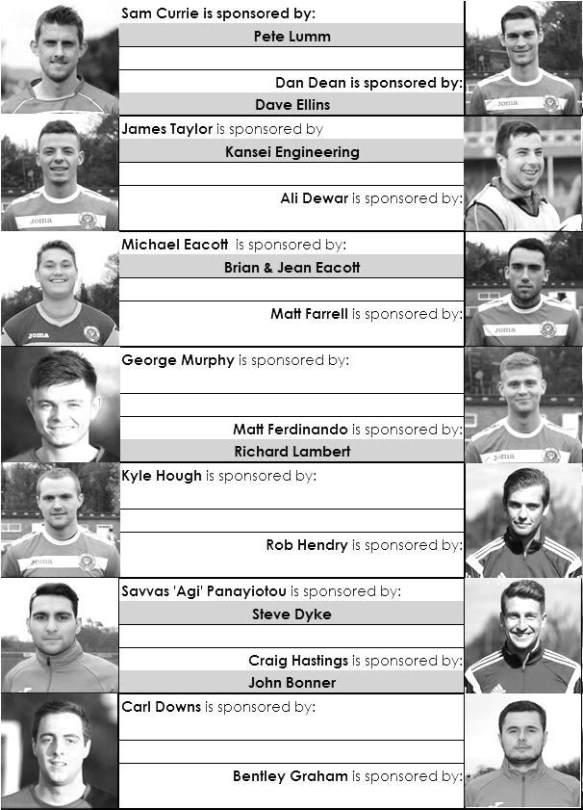

Here is the current list for the 2015/16 season showing all of our players and Management that are currently available for sponsorship this season.

Sponsorship costs just £40 and it is easy to do. Just select a player who has not been previously sponsored and let a Committee Member know that you would like to sponsor them. Beware though. Until we have received the money it is possible for someone to jump in front of you, so don’t delay, sponsor today!
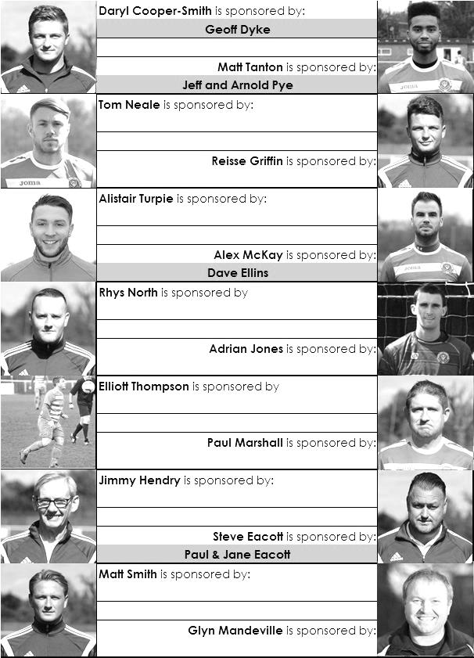

Match and Ball Sponsorships – 2015/16
Opponent | Date | Match Sponsor | Match Ball Sponsor
Hoddesdon Town | 18/07/15 | Geoff Dyke
Windsor | 08/08/15 | Club President - Stella Lamont
Erith & Belvedere (FAC) | 16/08/15 | Committee Member - Mike Lovett
Raynes Park Vale | 31/08/15 | EEFC Management Committee
Colliers Wood United | 08/09/15 | Bookham Building Shop – www.buildingshop.co.uk
AFC Hayes | 19/09/15 | John Bonner
Farnham Town | 26/09/15 | Ezara and Inaya Beddoe – our youngest supporters!
Chertsey Town | 17/10/15 | Club Media Officer – Richard Lambert
Dorking Wanderers (SSC) | 20/10/15 | Tony Ferdinando
Chessington & Hook United | 07/11/15 | Paul Merritt
Hanworth Villa | 21/11/15 | Maggie Beddoe
Guildford City | 05/12/15 | Pete Lumm
Sutton Common Rovers | 19/12/15 | Marvin Hough
Ashford Town (Mx) (LC) | 12/01/16 | Pete Beddoe & Steve Dyke
Redhill | 02/02/16 | David Lawton
Bedfont Sports | 13/02/16 | Bookham Building Shop – www.buildingshop.co.uk
Hartley Wintney | 23/02/16 | EEFC Management Committee
Horley Town | 27/02/16 | Jeff and Arnold Pye
Spelthorne Sports | 01/03/16 | In memory of Chris Henry
Knaphill | 12/03/16 | Marvin Hough
Cove | 15/03/16 | Mark & Carmel Murphy
Westfield | 26/03/16 | Nathan Lambert
Badshot Lea | 09/04/16 | Tony Coome
Camberley Town | 16/04/16 | Marvin Hough
Ashford Town (Mx) | 30/04/16 | Club President - Stella Lamont
Ashford Town (Mx) | 30/04/16 | Brian Eacott | Steve Dyke
For League, League Cup and Surrey Senior Cup Matches:
Match sponsorship - £40.00 Match ball sponsorship - £25.00. Combined £55.00.

We can still take more sponsors – Any game can have more, or why not sponsor a player?

Sponsorship includes: ( x2 for match, x3 for match and ball )

Admission, programmes, hospitality, advertising and mascot for the day (if required ).
If you are interested, just speak to a Committee Member, or drop me an email at: richard.c.lambert@gmail.com

We also thank our Kit Sponsors INTERCEM

Salts Super Six Predictor
The Salts Super Six Predictor Competition is live again and the tickets are on sale at today’s game to the left of the gate. We have now had three Super Six winners but the jackpot is building up again already!

The competition is easy to play! To win, you simply need to predict the results of the six matches correctly from the three options, fill in the form and make sure it is back with our sellers before the deadline on the ticket.

If you are a club regular, you just need to place your name on the sheet, although if you aren’t, then we’ll need a contact number from you too. We will announce any winners on the website very quickly, so don’t worry we won’t miss you!
The jackpot is already at £152 and who knows how high it could go this time!

Please note that if there is more than one winner, the prize pot would be shared between the winners. All you need to do now is have a go, as many times as you like!

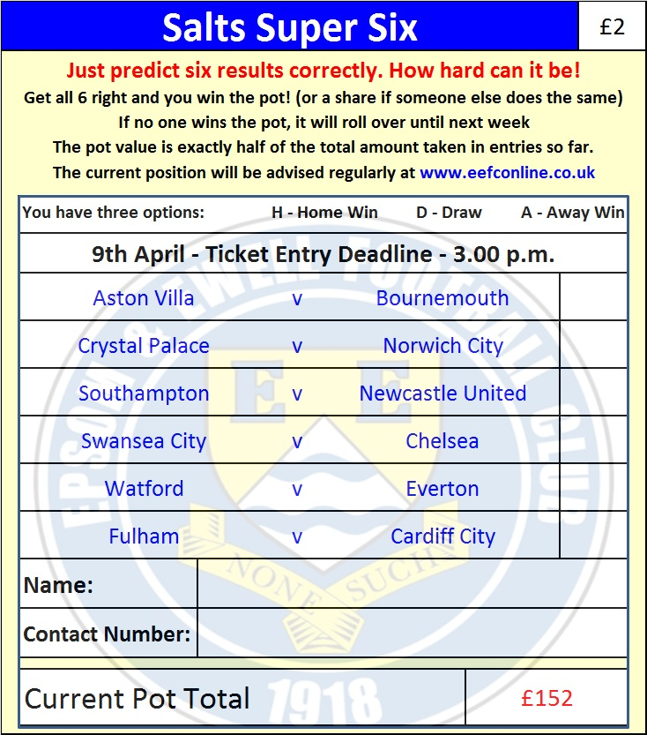

Good luck!

Combined Counties League – Premier Division
Saturday, 9th April 2016 - Kick-off 3.00 p.m.
Epsom and Ewell  (Royal Blue & White hoops) | V |  | Badshot Lea  (Claret / Blue )
Squad | NUMBERS
Michael Eacott |  |  | Pat Kinsella
© Sam Currie |  |  | Deane Sumbler
Matt Tanton |  |  | Jordan Stepney
Dan Dean |  |  | Kieran Maylen
Craig Hastings |  |  | Gabby Adelawo
Bentley Graham |  |  | Stuart Urquhart
Reisse Griffin |  |  | James Pilgrim
Matt Farrell |  |  | Darren Blake
Kyle Hough |  |  | Macauley Ford
Rob Hendry |  |  | Ryan Stephens
Matt Ferdinando |  |  | Paul Coventry
Rhys North |  |  | Gavin Muir
James Taylor |  |  | Mason Saunders
George Murphy |  |  | Zach Hawker
Tom Neale |  |  | Ross Frisby
Savvas ‘Agi’ Panayiotou |  |  | Jake Hawker
Alistair Turpie |  |  | Joe Connell
Alex McKay |  |  | Jon Palmer
Adrian Jones |  |  | Cameron Blackie
Carl Downs
Elliott Thompson
Glyn Mandeville | MANAGER |  | Ben Dillon
Matt Smith | ASSISTANT
Steve Eacott / Alex McKay / Jimmy Hendry | COACHES / PHYSIO |  | Jason Minton / Steve Saunders
REFEREE: J.Ohene (Brentford)
ASSISTANTS: D.Olugunna (Wallington), M.Ford (Sutton)
Today’s Match and Match Ball are sponsored by
one of our regular supporters, Tony Coome

OUR NEXT VISITORS TO HIGH ROAD ARE:
Camberley Town
Saturday 16th April 2016 - Kick-off 3.00 p.m.
Combined Counties League – Premier Division

